भारतमौसमविज्ञानविभाग |  | India Meteorological Department
Monday,02ndJune2025 (12Jyeshtha1947 Saka)
Summary of observations recorded at 0830 hoursIST:The Northern Limit of Monsoon continues to pass through 17.0°N/55°E, 17.5°N/60°E, 18°N/65°E, 18.5°N/70°E, Mumbai, Ahilyanagar, Adilabad, Bhawanipatna, Puri, Sandhead Island, 23.5°N/89.5°E, Balurghat, 30°N/85°E. The Western Disturbance as a cyclonic circulation over north Pakistan & adjoining Jammu between 3.1 km & 7.6 km above m. s. l. The upper air cyclonic circulation over Haryana & neighbourhood persisted and extended upto 1.5 km above m. s. l. The north-south trough ran roughly along Long. 91°E to the north of Lat. 22°N at 1.5 km above m. s. l. An upper air cyclonic circulation lay over east Bihar & neighbourhood at 1.5 km above m. s. l. A trough ran from east Uttar Pradesh to northeast Assam across central parts of Bihar, sub-Himalayan West Bengal & Sikkim and Assam at 0.9 km above m. s. l. The upper air cyclonic circulation over central Pakistan became less marked. The upper air cyclonic circulation over northeast Assam became less marked. The trough at mean sea level from central parts of east Uttar Pradesh to Arunachal Pradesh across central parts of Bihar, sub-Himalayan West Bengal, central parts of Assam became less marked. The trough from central Pakistan to cyclonic circulation over Haryana across north Rajasthan also became less marked.
Day temperatures were markedly above normal(> 5.1°C) at few places over Punjab; appreciably above normal(3.1°C to 5.0°C) at isolated places over sub Himalayan West Bengal & Sikkim, Odisha, west Uttar Pradesh and Himachal Pradesh; above normal(1.6°C to 3.0°C) at few places over Gangetic West Bengal and Bihar; at isolated places over Assam & Meghalaya, east Uttar Pradesh, east Madhya Pradesh, coastal Andhra Pradesh & Yanam, Tamil Nadu, Puducherry & Karaikal and Kerala & Mahe and near normal(-1.5°C to 1.5°C) at many places over Andaman & Nicobar Islands, Uttarakhand, Saurashtra & Kutch, Konkan & Goa and south interior Karnataka; at most places over Arunachal Pradesh, coastal Karnataka and Lakshadweep; at few places over Haryana-Chandigarh-Delhi, west Rajasthan, Gujarat region and Rayalaseema; at isolated places over east Rajasthan, west Madhya Pradesh, Telangana and north interior Karnataka. Yesterday, the highest maximum temperature of 41.9°C was reported at Sri Ganganagar (west Rajasthan).
The Southwest Monsoon has been active over Nagaland-Manipur-Mizoram-Tripura. It has been subdued over coastal Andhra Pradesh, Telangana, Rayalaseema, Tamil Nadu and south interior Karnataka.
Total 332 Station reported rainfall today. Total rainfall is 112.8 cm. Total 320 Station reported rainfall today whose normals are available. Total rainfall is 101.1 cm with normal station total is 120.9 cm.
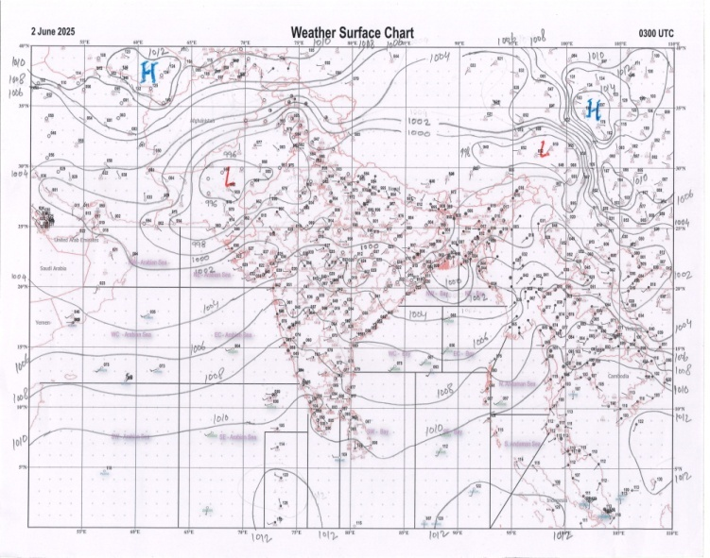 | 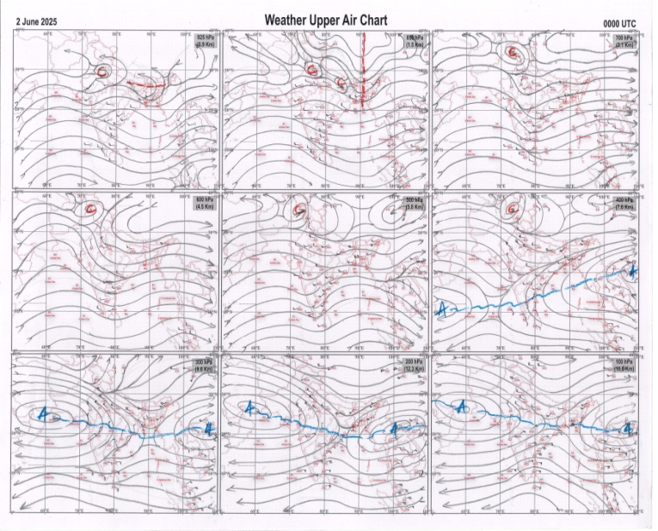
g.1. Analysed surface chart based on 03z observation | Fig.2. Analysed upper air chart based on 00z observation

Dr. S.D.Sanap
Scientist ‘D’
CR & S Office, Pune  Issued at 1245 hrs. IST |  | Weather Forecasting Division  CR&S, Pune

Indian regions | Realised rainfall (chief amount in cm during past 24 hrs):
East | most places: Arunachal Pradesh+, Nagaland-Manipur-Mizoram-Tripura+++ and Sub-Himalayan West Bengal & Sikkim+  many places: Assam & Meghalaya+  isolated places: Gangetic West Bengal, Odisha, Jharkhand and Bihar  Zunheboto AWS 12.3, Beech tea garden 10.0, Pasighat AP 8.8, Passighat AWS 8.7, Basar&Aizwal 8.5 each, Panbari 7.8, Newlands tea garden 7.2, Sabroom 7.1, Ranganadintxing 6.8, Balurghat 6.5, Basirhat (pt) 6.3, Andhratharhi&Narpatganj 6.0 each, Mawsynram 5.0, Nalhati 3.5, Rajmahal 3.3, Forbesganj 3.2, Berhampore 2.4, Maharo 2.1, Baripada 0.3.
North | a few places: Haryana  isolated places: Uttar Pradesh, Uttarakhand, Punjab◆, Himachal Pradesh, Jammu-Kashmir and Ladakh and Rajasthan  Kanina 5.4, Khushalgarh 3.7, Chikali SR 3.5, Ateli 3.0, Aligarh 2.9, Bilara 2.3, Jatton barrage 2.2, Paonta 1.9, Mussoorie 1.8, Safdarjung 1.7, Nohar SR 1.1, Rishikesh 1.0, Dharampur 0.9, Haripur &Pahalgam AWS 0.8 each, Agra 0.7, Ghorawal& Sikar 0.6 each, Elgin bridge &Chhata 0.5 each, Churu tehsil SR 0.4, Batkoot ARG 0.3, Gulmarg RS 0.2, Hoshiarpur AWS & Thein dam AWS 0.1 each.
Central | isolated places: Madhya Pradesh, Vidarbha◆ and Chhattisgarh  Pratappur 3.6, Nagode 2.4, Raoti 2.2, Sohawal 1.8, Satna (raghurajnagar) 1.3, Dourakochali 1.2, Ratlam-aws 0.8, Lahar 0.4, Paratwada&Jashpurnagar 0.2 each, Chikhalda 0.1.
Peninsula | most places: coastal Karnataka  many places: Konkan & Goa  a few places: Kerala  isolated places: Gujarat Region, Madhya Maharashtra, Marathwada, coastal Andhra Pradesh◆, Telangana, Rayalaseema, Tamil Nadu and interior Karnataka  dry weather: Saurashtra & Kutch  Sandhiyurkvk AWS 4.3, Karjat ARG 4.2, Bayar AWS 4.1, Dapoli ARG &Kumta 3.5 each, Gokarna 3.4, Fatepura 3.3, Matheran, Gaganbawada&Ayyankunnu AWS 3.1 each, Meghraj, Mahabaleshwar &Shahuwadi 3.0 each, Honavar 2.8, Gandhinagar 2.5, Agumbe emo 2.3, Kammardi 2.2, Kottigehara 2.0, Hakimpet IAF 1.6, Kannur 1.5, Satyavedu 1.4, Kodaikanal 1.2, Singampunari 1.1, Londa 1.0, Chakur 0.9, Chegunta, Kambadur&Chikodi 0.8 each, Yadagirigutta& Belagavi PTO 0.7 each, Parbhani 0.5, Dharashiv IMD parttime 0.3, Prattipadu (ARG) & Tirupati AP 0.1 each.
Islands | a few places: Andaman & Nicobar  isolated places: Lakshadweep◆  Iafcarnicobar 1.8, Hut bay 1.1, Maya bandar 0.8, Agathi 0.2, Amini& Minicoy 0.1 each.
Table 2.Forecast/warnings (distribution of rain / thundershowers) for 7 days (valid from time of origin upto 0830 hrsIST of next day)
Sr. No |  | Sub-division Name | Day 1 | Day 2 | Day 3 | Day 4 | Day 5 | Day 6 | Day 7 | Sr. No. | Sub-division Name | Day 1 | Day 2 | Day 3 | Day 4 | Day 5 | Day 6 | Day 7
 |  |  | 02Jun | 03Jun | 04Jun | 05Jun | 06Jun | 07Jun | 08Jun |  |  | 02Jun | 03Jun | 04Jun | 05Jun | 06Jun | 07Jun | 08Jun
 | 1 | Andaman Nicobar Islands | W | F | F | W | W | W | W | 19 | west Madhya Pradesh | I  | S  | S  | I  | I  | I | I
 | 2 | Arunachal Pradesh | W ++  | W +  | F +  | F | F | F | F | 20 | east Madhya Pradesh | I  | I  | S  | I  | I  | I | I
 | 3 | Assam-Meghalaya | W ++  | W ++  | W +  | W +  | F | F | F | 21 | Gujarat region | S  | S | S | I | I | I | I
 | 4 | Nagaland-Manipur-Mizoram-Tripura | W ++  | W ++  | W +  | W +  | F | F | F | 22 | Saurashtra and Kutch | I | I | I | I | I | I | I
 | 5 | Sub Himalayan West Bengal/Sikkim | W +  | W  | W  | F | F | F | F | 23 | Konkan and Goa | F | F + | S | I  | I | I | S
 | 6 | Gangetic West Bengal | I + | I + | I + | S | I | I | I | 24 | Madhya Maharashtra | I | I | I  | I  | I  | I | I
 | 7 | Odisha | I + | I + | I + | I + | I + | I | I | 25 | Marathwada | I | I | I  | I  | I | I | I
 | 8 | Jharkhand | I  | I  | I  | I | D | D | D | 26 | Vidarbha | I | I  | I  | I  | I  | I | I
 | 9 | Bihar | I  | I  | I  | I | D | D | I | 27 | Chhattisgarh | I  | I  | I  | I  | I  | I | I
 | 10 | east Uttar Pradesh | I  | S  | I  | D | D | D | D | 28 | Coastal Andhra Pradesh and Yanam | I+ | I+ | I+ | I | I | I | I
 | 11 | west Uttar Pradesh | S  | S  | I  | I | D | D | D | 29 | Telangana | I  | I  | I | I | I | I | I
 | 12 | Uttarakhand | S  | F +  | S  | I  | I | D | D | 30 | Rayalaseema | I | I | I | I | I | I | I
 | 13 | Haryana,Chandigarh and Delhi | S  | F +  | I | D | D | D | D | 31 | Tamil Nadu, Puducherry and Karaikal | I + | I + | I + | I | I | I | I
 | 14 | Punjab | S  | F +  | I | D | D | D | D | 32 | Coastal Karnataka | W  | W  | W | F | S | S | S
 | 15 | Himachal Pradesh | S  | F  | F  | S  | I | I | D | 33 | North interior Karnataka | I  | I  | I  | I  | I | I | I
 | 16 | Jammu-Kashmir and Ladakh | F  | F  | S | I | D | D | D | 34 | South interior Karnataka | I  | I  | S  | S  | I | I | I
 | 17 | west Rajasthan | I  | S  | I  | I  | D | D | D | 35 | Kerala and Mahe | F + | W +  | F + | S | S | S | S
 | 18 | east Rajasthan | S +  | S +  | I  | I  | I  | I | I | 36 | Lakshadweep | F | F  | F | S | S | S | S
Legends: D = DryI = IsolatedS = ScatteredF = Fairly widespreadW = Widespread#= heavy to very heavy rain at a few places with extremely heavy rain at isolated places+++= heavy rain at a few places with very heavy rain at Isolated places++= heavy to very heavy rainfall@=Isolated exceptionally heavy rainfall+ = heavy rain●/*= rain or snow♦ = very light rain≡=fog= thunderstorm with lightning=Squall / Gusty / gale / strong wind­ =cold wave/cold day+= heat wave/warm night/hot and humid weather=Duststorm=ground frost = Hail

Fig. 4: Districtwise warnings for five days for Maharashtra State
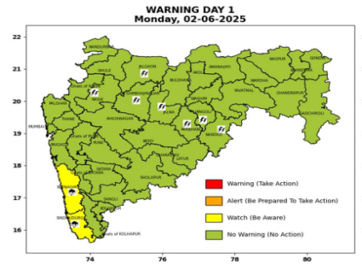 | 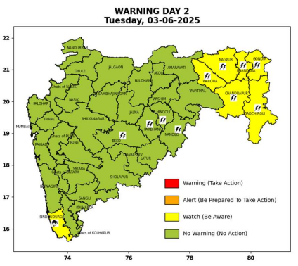 | 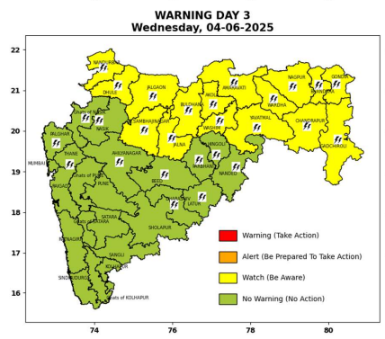 | 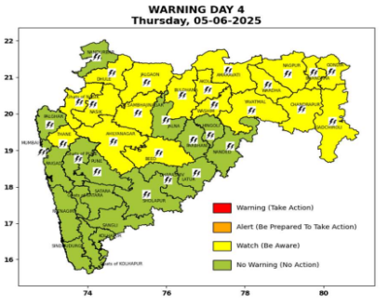 | 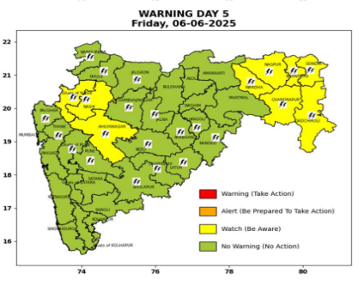

Pune, Lohegaon and Pashan observations at 0830 hrs. IST of Today
 | Temperature (°C) |  |  |  |  | Humidity (%) |  |  |  | Rainfall (mm)
 | Max.  past  24 hrs | Dep.  from  normal | Min.  past  24 hrs. | Dep.  from  normal | Dry  Bulb | At 0830 hrs. IST | Dep.  From  normal | At 1730  hrs. IST of y’day | Dep.  from  normal | Past  24 hrs. | Since  1st June | Dep.  from  normal
PNE | 29.5 | -6.2 | 21.5 | -2.1 | 26.2 | 76 | 7 | 70 | 19 | 1.2 | 1.2 | -5.2
PSN | 29.0 | - | 20.5 | - | 25.2 | 84 | - | 75 | - | 0.2 | 0.2 | -
LHG | 31.3 | -2.7 | 24.1 | 3.1 | 27.6 | 63 | -6 | 61 | 10 | 4.0 | 4.0 | -2.8

 |  |  |  |  |  |  | Local (Pune and neighbourhood) forecast
Max./Min. Temperature (°C) |  |  |  |  |  |  |  |  | Weather
Date | Pune | Pashan | Lohegaon | Chinchwad | Lavale | Magarpatta | NDA | Koregoan Park
02/06/25 | 32/21.5* | 32/20.5* | 34/24.1* | 32/22.6* | 31/21.7* | 34/24.2* | 32/22.2* | 32/23.3* | Mainly clear skybecoming partly cloudy sky towards afternoon/evening.
03/06/25 | 32/21 | 32/21 | 34/24 | 31/23 | 31/22 | 34/24 | 32/22 | 32/23 | Mainly clear sky becoming partly cloudy sky towards afternoon/evening.
04/06/25 | 32/21 | 32/21 | 34/24 | 31/23 | 31/22 | 34/24 | 32/22 | 32/23 | Mainly clear sky becoming partly cloudy sky towards afternoon/evening.
05/06/25 | 31/22 | 31/22 | 33/25 | 30/24 | 30/23 | 33/25 | 31/23 | 31/24 | Mainly clear sky becoming partly cloudy sky towards afternoon/evening.Thunderstorm with lightning, light rain likely.
06/06/25 | 30/23 | 30/23 | 32/26 | 29/25 | 29/24 | 32/26 | 30/24 | 30/25 | Mainly clear sky becoming partly cloudy sky towards afternoon/evening. Thunderstorm with lightning, light rain likely.
07/06/25 | 30/23 | 30/23 | 32/26 | 29/25 | 29/24 | 32/26 | 30/24 | 30/25 | Mainly clear sky becoming partly cloudy sky towards afternoon/evening. Thunderstorm with lightning, light rain likely.
08/06/25 | 30/23 | 30/23 | 32/26 | 29/25 | 29/24 | 32/26 | 30/24 | 30/25 | Mainly clear sky becoming partly cloudy sky towards afternoon/evening. Thunderstorm with lightning, light rain likely.
Rainfall Distribution |  |  | Rainfall Categories | Rainfall (mm) |  | Cloud condition |  |  |  | Rainfall Intensity |  | Range
Widespread (W) | 76-100% |  | Very Light rain | Trace to 2.4 mm |  | Mainly clear sky |  | 1-2 oktas |  | Light Spell |  | 1 cm/hr
 |  |  | Light rain | 2.5 to 15.5 mm |  | Partly cloudy sky |  | 3-4 oktas |  | Moderate Spell |  | 1-2 cm/hr
Fairly Widespread (FW) | 51 – 75% |  | Moderate rain | 15.6 to 64.4 mm |  | Generally cloudy sky |  | 5-7 oktas |  | Intense Spell |  | 2-3 cm/hr
Scattered (S) | 26 – 50% |  | Heavy rain | 64.5 to 115.5 mm |  | Overcast |  | 8 oktas |  | Very Intense Spell |  | 3-5 cm/hr
isolated (I) | 1 – 25% |  | Very heavy rain | 115.6 to 204.4 mm |  |  |  |  |  | Extremely Intense Spell |  | 5-10 cm/hr
D (D) | No Rain |  | Extremely heavy rain | ≥ 204.5 mm |  |  |  |  |  | Cloudburst |  | > 10 cm/hr
Probability Terms in %: |  |  | Heavy snow | 6.5 to 11.5 cms water equivalent of rain
unlikely | < 25 |  | Very heavy snow | 11.6 to 20.4 cms water equivalent of rain
likely | between 25 50
very likely | between 51 75
most likely | >75
* = realized temperature
Mumbai (Colaba) |  |  |  | Nagpur (AP)
Date 2025 | T max °C | T min °C | Weather | T max °C | T min °C | Weather
02/06 | 33 | 27 | Generally cloudy sky with Light Rain or Drizzle. | 38 | 27 | Partly cloudy sky.
03/06 | 33 | 27 | Generally cloudy sky with Light Rain or Drizzle. | 38 | 27 | Rain orThunderstorm accompanied with lightning & gusty winds(40-50kmph).
04/06 | 33 | 27 | Generally cloudy sky with Light Rain or Drizzle. | 38 | 27 | Rain orThunderstorm accompanied with lightning & gusty winds(40-50kmph).
05/06 | 34 | 26 | Generally cloudy sky with moderate rain. | 38 | 27 | Rain orThunderstorm accompanied with lightning & gusty winds(40-50kmph).
06/06 | 34 | 26 | Generally cloudy sky with moderate rain. | 38 | 27 | Rain orThunderstorm accompanied with lightning & gusty winds(40-50kmph).
07/06 | 33 | 26 | Rain. | 38 | 27 | Partly cloudy sky.
08/06 | 33 | 26 | Rain. | 39 | 28 | Partly cloudy sky.

